Lutheran Social Services of Wisconsin and Upper Michigan (LSS) History
In 1882, Pastor Even Johnson (E.J.) Homme, founded LSS. He had traveled to an isolated part of northern Wisconsin and saw children, the elderly, and individuals struggling to survive and needing support. Empowered by The Lutheran Church in America, Pr. Homme courageously established Wittenberg, WI. With hard work, ingenuity, and a tremendous amount of faith, he set up the first Homme Home. He then inspired forty members of his family and congregation to relocate to Wittenberg and help strengthen the town’s most vulnerable populations. This safe, stable, and loving Home provided strength to people that needed a place to live, learn, and grow into the people God intended them to be.
Community Needs
Undiagnosed and untreated mental illness has reached epidemic proportions around the country and in Wisconsin. However, approximately one-third of Wisconsin children and youth with any mental-health problem have not received treatment. LSS is at the forefront of addressing mental health challenges through trauma-informed social programs located throughout 82% of our state. Furthermore, these programs identify barriers impacting social determinants of health (SDOH).
In December 2021, the U.S. Surgeon General declared a national youth mental health crisis. Effects of the COVID-19 pandemic have highlighted a rise in mental health symptoms compounded by increasing violence experienced by children and adolescents, including domestic violence and fears over school shootings. Research confirms that the effects of stress are felt more acutely by children who live in families experiencing poverty. At least one in ten of Wisconsin’s 1.2 million children lives in poverty, and one in three is on Medicaid. (Wisconsin Office of Children's Mental Health 2022).

Those children most in need of mental health interventions are very often those least likely to receive them. The U.S. DHHS confirms that children from traditionally underserved backgrounds experience higher rates of mental health issues and face greater barriers to accessing care. Of those children who do receive mental health treatment, it is estimated that 75% of the time they receive care at school. However, Wisconsin schools continue to experience a shortage of school-based mental health professionals (Wisconsin Department of Public Instruction). Due to the complexities of the Medicaid and commercial insurance systems, those children who can access mental health services face challenges in securing funding for treatment.
LSS Model: SCMH
LSS SCMH addresses the root causes (e.g., toxic stress) of issues like failing grades, poor graduation rates, and decreases in post-secondary learning, helping to break the cycle of poverty, homelessness, physical and mental illness, etc. for all students and the families who love them. One challenge for the students is that 44% of SCMH participants have 4 or more Adverse Childhood Experiences (ACEs). This is in comparison to the national average of 16% of adults who have 4 or more ACEs. ACEs are traumatic events that occur in childhood that can have a tremendous impact on lifelong health and opportunities. Having four or more greatly increases those risks.
Piloted in 2018 with two schools and now serving nine in the city of Milwaukee, SCMH removes barriers to treatment for youth who are impacted by disparities and healthcare inequity. The program is changing the mindset of how practitioners address children’s mental health. Instead of relying on one school-based therapist for clinical services for students, it utilizes schools as a health and wellness connector for students, their families, and the community.
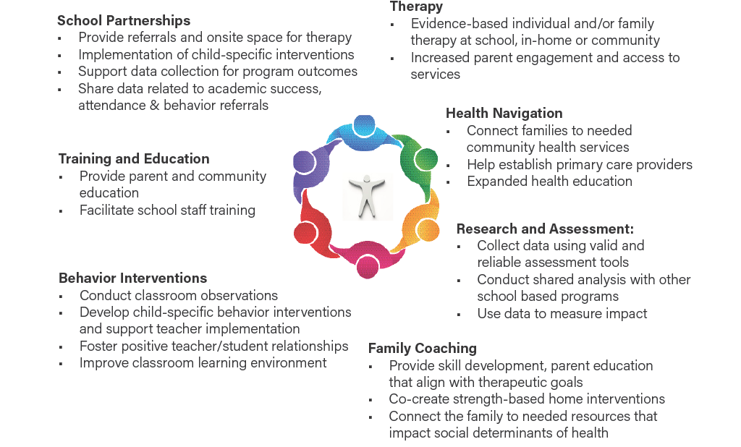
Through targeted case management and customized services offered by the Family Coach along with a Therapist/Behavior Interventionist, the SCMH team appropriately supports, guides, advocates and offers tools for students and families in school and at home based on their individual strengths and needs. SCMH provides trauma informed therapy and interventions. Furthermore, its Parent Café offers a safe space for all families to meet, talk, and support each other through life challenges.
SCMH Partners
Partners with community health systems provide preventative health focused home visits, medication monitoring and care coordination with physicians and other medical providers. Furthermore, the program is reliant on the following partners:
- Marquette University Center for Peacemaking
- Milwaukee Public Schools
- New Beginnings are Possible
- United Community Center
Innovative and Impactful Approach to Mental Well-Being.
SCMH is mitigating the effects of traumas through its family coach model – a holistic approach that decreases the community, school, and family stressors that impede well-being and academic success. The program includes students, their families, a therapist, and school faculty to create improvements in social determinants of health with the following results.
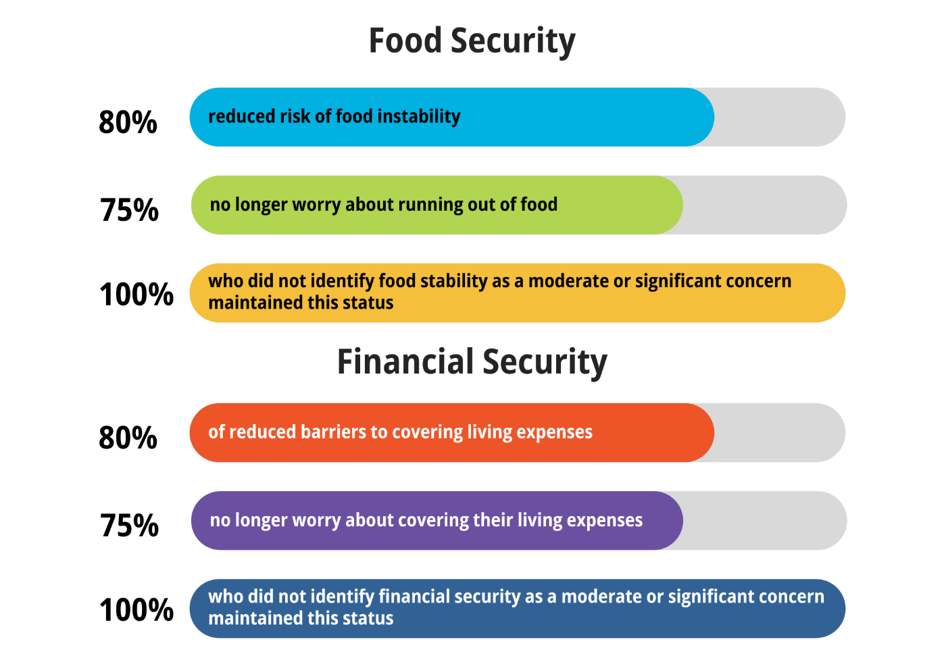

In the 2022-2023 academic year, SCMH will serve students and their families in some of the areas of Milwaukee where barriers to social determinants of health are the greatest including:
- Three schools at the United Community Center on the city’s near south side
- Four MPS schools and the MPS Success Center all located in the 53206 area code, Milwaukee’s most distressed neighborhood
- Marvin E. Pratt Elementary School, an MPS school in the Lincoln Park neighborhood
- Ralph H. Metcalfe School, an MPS school in the Metcalfe Park neighborhood
Results at School
SCMH is an effective and high-level mental health service for students and their families. It has provided timely, quality, culturally sensitive, bilingual (at UCC schools) support to students and parents, even throughout the pandemic. The results are evident in the classroom as reported by our partner schools:
- Increased school attendance
- Decreased office referrals for behaviors
- Decrease suspension from school
- Statistically significant improvement in academics as measured by the STARs testing
- Improvement in mental health as measured via SDQ
Success Stories
Before being referred to SCMH, a sixth grader at UCC had received services from a community mental health center but his mental health continued to deteriorate. Extended periods of no face-to-face schooling for this child, who already had trouble connecting with peers and was often bullied, were causing isolation and depression. Severe depression in children can lead to psychosis, and he was beginning to have auditory and visual hallucinations. He was also exhibiting self-harm behaviors. His mother’s response was to offer him extra comfort and love. The SCMH Family Coach helped her understand the other steps needed for her son’s recovery, including appointments with a psychiatrist. Furthermore, weekly meetings with the SCMH therapist guided him on how to make friends and successfully connected him with another student in the program. Many of his symptoms may have continued to go undiagnosed and untreated without SCMH. This sixth grader is now well on the road to recovery.
Another student had severe anxiety leading him to often run out of the school building. The SCMH team worked with the student, his family, and his teachers to better understand the mental health challenges that affected his behavior. The therapist created strategies for managing his anxiety that could be practiced at home and at school. These strategies addressed the anxieties and empowered the student to be in charge of his own recovery. His family noticed improvement very quickly and expressed their gratitude to the SCMH team. The teachers reported that the student is starting to enjoy school and could focus on his learning more as the anxiety becomes more manageable.

SCMH services impact communities by reducing health disparities for children and families. When a child’s mental health needs can be addressed and families can decrease significant or moderate SDOH needs, communities will see decreased demand on emergency services including law enforcement, housing services, emergency departments, and emergency food providers. Additionally, children who are mentally healthy will have better academic and social outcomes which can lead to decreases in out-of-home care placements, drop-out rates, and contacts with juvenile justice. Families whose basic needs are met can begin to focus on education and employment. These improvements to child and family health help to create stronger communities.
Funding Request
Create a pilot program in the 2025-2027 biennium that will provide support for 2 schools to offer SCMH.
The total budget request is $856,000 to fund two years at two schools. Each school will require $214,000 per year to fund the model. This funding will support a full-time therapist and a family coach plus supervision at each school.
The pilot program will serve the most at risk students and families at each school. The program team will maintain an active caseload of approximately 25 per school reaching between 30 to 40 students in a school year. The comprehensive model will engage the family around the identified child, including parents, grandparents, siblings, and other identified supportive individuals and will provide services year-round.

